3 6 9 a i . B i z

369 Showroom Check

User Guide
Walk a round, capture the room, and send it in.

About This Guide
This guide is for the person who walks the rounds. It covers everything you can do on the phone: signing in, capturing a round, and sending it in.
You do not need any technical knowledge. You do not have to judge whether the room is right - you capture it honestly, and the system does the comparing.
Two tabs sit along the bottom of your screen: Dashboard and Profile. That is the whole app for you. If you have been told about a History or Compare tab, those belong to managers and will not appear on your phone.
TIP Everything the app shows comes from your server as you look at it. There is no offline mode - if you have no signal, the round cannot be captured or sent.

Your Round at a Glance
▪ Open the app - the Dashboard tells you whether a round is open right now.
▪ Wait for the window - a round can only be captured between its start and end times.
▪ Tap Capture now - and choose Photos or Video if you are offered the choice.
▪ Capture the room - one sweep with the camera, or one photograph per view.
▪ Stay until it says Sending - nothing reaches the server until the upload finishes.
▪ Check it turned green - the round flips to Recorded on the Dashboard.

PART 1 GETTING STARTED

Step 1 Sign In to Your Workspace
You only do this once. The app remembers you afterwards.
Type the address your manager gave you into Server address. You do not need to press anything - the app checks the server on its own about a second after you stop typing, and a green tick appears in the field when it answers.
Pick your Database if the app offers a list. Where the server hosts only one, it is chosen for you. Then fill in Username and Password and tap Sign in.
The button reads Connect to server until the server answers, and changes to Sign in once it has. If the check fails, a Try again now link appears underneath.
What are you looking at? | What it means
Server address | Where your workspace lives. An address or an IP, with a port if your manager gave you one.
Database | Which workspace on that server. Ask your manager if more than one is listed.
Username and Password | Your own login. Passwords are case-sensitive.
Connect to server / Sign in | The same button. It changes wording once the server has answered.
Your credentials are sent directly to your server and stored only on this device. | Nothing is sent anywhere else, and nothing is kept off your phone.

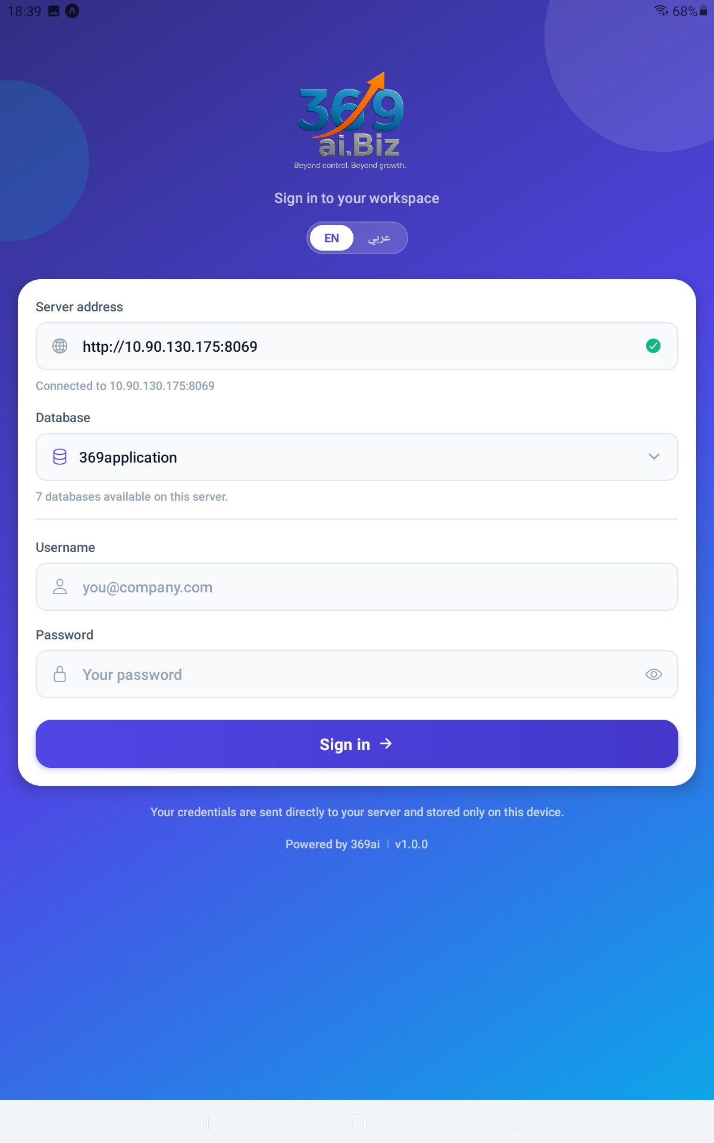
Figure 1. The sign-in screen, with the server already connected and the database chosen.

IMPORTANT If you see Showroom Check is not installed on this database, you have picked the wrong workspace. Choose another database, or ask your manager which one to use.

Step 2 Find Your Way Around the Dashboard
The Dashboard is the screen you will live on. The band at the top greets you by name and shows today's date and the office timezone - not your phone's.
The ring shows how many of today's rounds are done, as 2/7 RECORDED. Beside it, a red chip counts rounds that were never captured.
Below that, a large card tells you what matters right now. It reads Open now when a round is ready for you, or Up next with a countdown when the next one has not opened yet. Under the card, every round for today is listed with its own badge.
What are you looking at? | What it means
Open now | This round is ready. Tap Capture now and go.
Up next with Opens in 1h 14m | Nothing to do yet. The countdown is a prediction, not permission.
Upcoming | Scheduled for later today. Its Capture button is greyed out.
Missed with This round was not recorded. | The window closed with nothing captured. Tell your manager if you were prevented.
Recorded | Done. A Watch button appears so you can play back your own round.
All done | Every round for today has been captured.

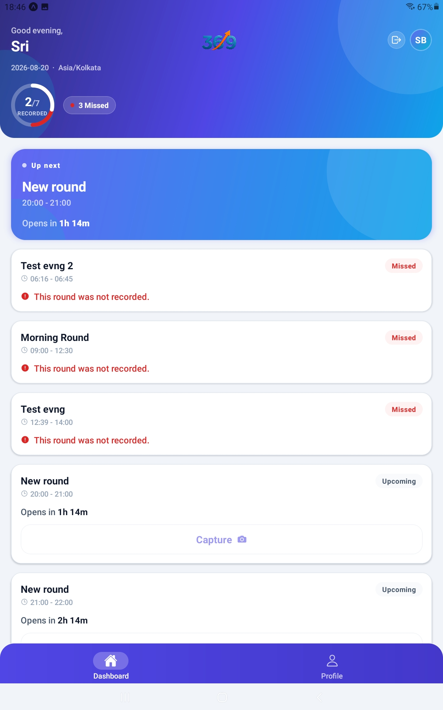
Figure 2. The Dashboard, showing the progress ring, the missed count, the next round, and today's rounds.

TIP The countdown reaching zero does not switch the button on by itself. The card shows Opening... and Checking with the server. while it asks - the server has the final say on whether a window is open.

PART 2 CAPTURING A ROUND

Step 3 Choose Photos or Video
Tap Capture now on the open round. The first time ever, the phone asks for the camera - tap Allow camera. The microphone is never requested, because no sound is ever recorded.
If your workplace allows both ways, a Photos and Video switch sits above the main button, with Video already chosen. Tap either one. You can change your mind right up until you start.
If you only see one option, your workplace is set up for that one way only.
Which should you pick? | When it suits
Video | Faster. One slow turn on the spot covers every view at once.
Photos | Better when the room is awkward to sweep, or the light is poor.
Neither is "better" | Both are checked against the originals in exactly the same way, and give the same kind of result.

[ IMAGE 3 - screenshot to be added ]
Figure 3. The ready screen, showing the Photos / Video switch above the main button.

IMPORTANT If you have already taken photographs and then switch, the app asks Change how you capture? and warns you they will be discarded. Tap Discard and change to go ahead, or Cancel to carry on as you were.

Step 4 Record a Video Sweep
Tap Record now. Recording starts straight away.
Turn slowly on the spot, letting the camera pass across every part of the room. The screen reminds you: Turn slowly so the camera passes every view. A pill counts the seconds as 0:07 / 0:30, and a red bar fills alongside it.
If your workplace has views set up, their names appear as chips along the bottom and tick green as you turn past each one. Use them to check you have not missed a wall.
What are you looking at? | What it means
0:07 / 0:30 | Seconds recorded, against the length your manager set.
The view chips | Guidance from the phone's motion sensor. They tick as you sweep past each view.
Stop | Pauses the recording on most phones. The buttons then become Continue and Finish now.
Finish now | Ends the clip and takes you to the review screen.
This phone cannot sense turning, so go by the direction above. | Your phone has no motion sensor. The round still works - just cover every wall yourself.

[ IMAGE 4 - screenshot to be added ]
Figure 4. Recording in progress, with the timer, the progress bar, the view chips and the Stop button.

IMPORTANT Stop does not always stop. On most phones it pauses, and Finish now is what ends the clip. If you meant to finish, check which button you are looking at.

Turn slowly. A fast sweep blurs the picture, and a blurred frame is harder to compare than a steady one.

Step 5 Check the Recording Before You Send It
When the clip ends you are not finished. The app plays it back to you first, under Check the recording.
Watch it through. The view names run along the bottom and light up as the playback reaches each one, exactly as they did while you were filming, so you can see for yourself which walls the sweep actually covered. Use Play and Pause, or Back five seconds and Forward five seconds to jump about.
Then decide. Use it sends the round. Record again throws the clip away and starts the sweep over.
What are you looking at? | What it means
Check the recording | The clip you just took, before anything is sent.
The view names along the bottom | They light up as playback reaches each view. A name that never lights means the sweep missed that wall.
Back five seconds / Forward five seconds | Jump about without scrubbing through the whole clip.
Use it | Accepts the clip and starts the upload.
Record again | Discards it and starts the sweep from the beginning.
[ IMAGE 5 - screenshot to be added ]
Figure 5. The review screen, showing the clip playing back with the view names underneath.
TIP This is the moment to catch a sweep that pointed at the floor, or missed a wall. Once a round is sent it is filed for the day, and only a manager can delete it so it can be walked again. Checking here costs you thirty seconds.

Step 6 Photograph Each View
In Photos mode the app walks you through the views one at a time. The top of the screen shows Step 1/4, so you always know how many are left.
For each view, a large arrow and the direction name tell you where to turn. A meter fills as you turn and reads Facing the view when you get there. Tap How it should look at any time to see the original full-screen.
Take the picture with the round white shutter, then tap Use it to keep it or Retake photograph to try again.
What are you looking at? | What it means
Step 1/4 | Which view you are on, and how many there are altogether.
How it should look | Opens the original for this view, full-screen. Tap anywhere to close it.
Turn until you face this view / Facing the view | The turn meter. Guidance only - the shutter works whatever it says.
Retake photograph | Throws this shot away and lets you take it again. Nothing has left the phone yet.
Use it | Accepts the shot and moves to the next view.
Starting the camera... | The camera is warming up. Wait a moment.

[ IMAGE 6 - screenshot to be added ]
Figure 6. A direction step, showing the arrow, the turn meter, the original button and the shutter.

TIP You are asked for exactly one photograph per view your manager has set up. If a view has no original photograph on the server, you are never asked for it at all.

Step 7 Send the Round
When the last step is done, the app uploads everything in one go and shows Sending... with a percentage.
When it finishes, the camera simply closes and you are back on the Dashboard. There is no success message - the proof is the round turning to Recorded.
What could go wrong? | What to do
You walk out of signal mid-upload | The round is lost. Move somewhere with signal and capture it again.
You tap the X part way through | The app asks Leave this round? first, and warns that what you captured will be discarded.
The window closes before you finish | The server refuses the round. Tell your manager - the round will show as missed.
Nothing appears to happen after upload | Check the Dashboard. The round should now read Recorded.

[ IMAGE 7 - screenshot to be added ]
Figure 7. The upload in progress, showing the Sending percentage and its bar.

IMPORTANT Nothing is saved on the server until the upload finishes. There is no draft and no resume. If you leave part way through, the round has to be done again from the first view.

PART 3 AFTER THE ROUND

Step 8 Watch Your Own Round
Once a round is captured, a Watch button appears on its card on the Dashboard. Tap it to play the clip back and see the photographs, with how closely each view matched its original.
You can only open your own rounds. A colleague's round shows Recorded by their name, but no Watch button.
What are you looking at? | What it means
As expected | The view matches its original. Nothing to do.
Worth a look | A little different. Glance at the two pictures.
Something has changed | Clearly different from the original.
Could not line up | The two pictures could not be matched - usually the framing was too different. The score means little.
Not compared | No comparison was possible for that view.
Similar: 65% | How much of the same thing is in both pictures.
Match: 79% | Whether anything has actually moved. Only shown once the two pictures lined up.

TIP A low score is not an accusation. It means the two pictures differ - which can be a real change, or simply that you stood somewhere different. That is exactly why both pictures are shown side by side.

Step 9 Your Profile, Language and Help
Tap Profile in the tab bar, or the circle with your initials at the top of the Dashboard.
The badge under your name reads Internal user. Below that, Account Details shows your user ID, username, database and the server you are connected to.
Tap EN or عربي to switch the whole app between English and Arabic, including the reading direction. The choice is saved on your phone.
What are you looking at? | What it means
Internal user | Your access level. Managers see Administrator here instead.
EN / عربي | Switches the app's language instantly. Round names and view names stay as your manager typed them.
Help | Opens the guides your workplace has published, including this one.
Log out | Signs you out. You will need your password to get back in.

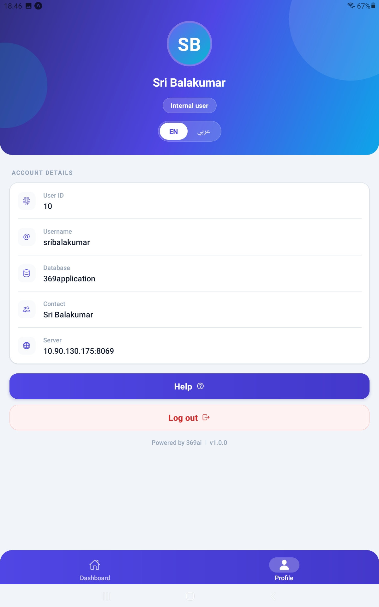
Figure 8. The Profile tab, showing the access badge, the language switch and the account details.

IMPORTANT Do not tap Log out unless you mean it. The app warns you: You will need your password again to log back in.

QUICK REFERENCE
If you want to... | Do this
Start a round | Dashboard → Capture now on the open round
Switch between photos and video | Tap Photos or Video above the main button
End a video clip | Stop, then Finish now
Watch a clip back before sending | It happens on its own - Check the recording
Throw a clip away and re-record | Record again on the review screen
Retake one photograph | Retake photograph before you tap Use it
Abandon a round | The X, then Leave on the warning
Play back your own round | Watch on that round's card
See why a round was missed | The red Missed chip counts them; the card says so
Change language | Profile → EN or عربي
Read the guides | Profile → Help

Things to Remember
▪ Nothing is saved until Sending... finishes. Leaving part way loses the whole round.
▪ Stop pauses on most phones. Finish now is what actually ends the clip.
▪ A clip is shown back to you before it is sent. Use that to catch a bad sweep, because once a round is sent only a manager can undo it.
▪ A round can only be captured inside its window, and only once a day.
▪ There are no reminders or notifications. Open the app to find out whether a round is waiting.
▪ The app needs a signal for everything. There is no offline mode.
▪ You cannot delete or edit a round once it is sent - only a manager can.
▪ You see that a colleague recorded a round, but never their video.
▪ The turn meter and the view chips are guidance. The shutter always works.
▪ No sound is ever recorded, and the microphone is never requested.
▪ Times shown are the office's timezone, not your phone's.
Capture the room honestly, stay until it says Sending, and check the round turned green.

--- End of Guide --- 369ai.Biz | 369 Showroom Check - User Guide

